A
PROFESSORA: Fernanda e Jéssika.___________

4º Ano – Fundamental I

COLÉGIO SANTA DOROTÉIA
Educar, um gesto de amor que fica para sempre.
Disciplina: Língua Portuguesa.

Nota:
Data: / /
Nº:
Nome:

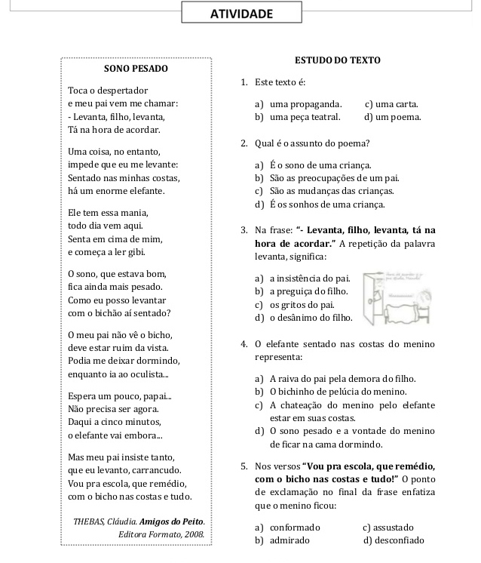

Ortografando!

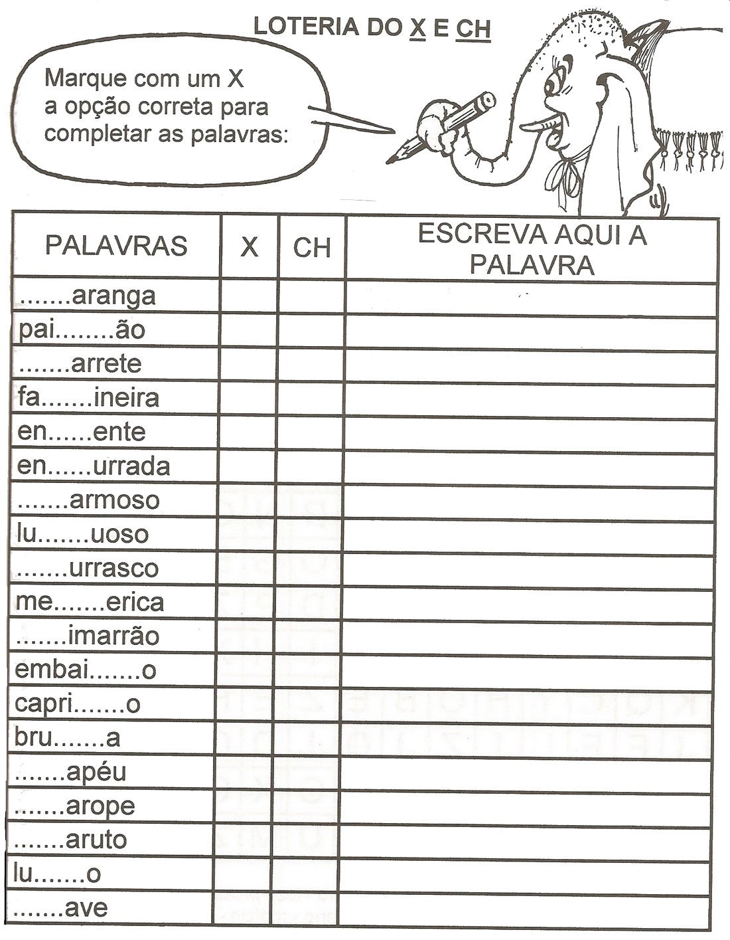

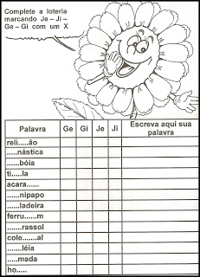

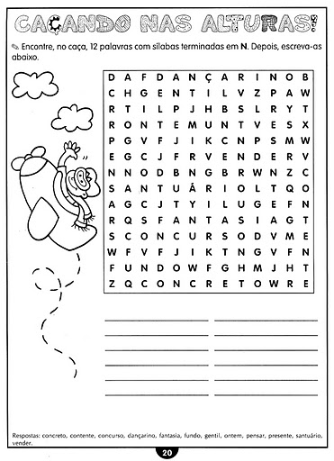

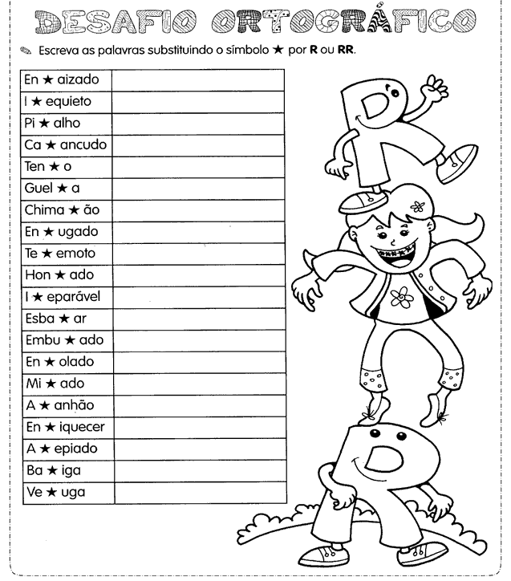

- Complete com M ou N:

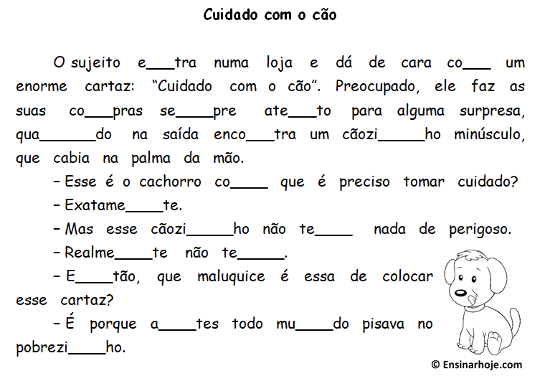

-Reescreva o texto, utilizando as palavras corretas:
____________________________________________________________________________________________________________________________________________________________________________________________________________________________________________________________________________________________________________________________________________________________________________________________________________________________________________________________________________________________________________________________________________________________________________________________________________________________________________________________________________________________________________________________________________________________________________________________________________________________________________________________________________________________________________________________________________________________________________________________________________________________________________________________________________________________________________________________________________________________________________________________________________________________________________________________________________________
_____________________________________________________________________________________________________________________________________________________________________________________________________________________________________________________________________________________________________________________

- Tenha muita atenção e descubra os 7 erros:

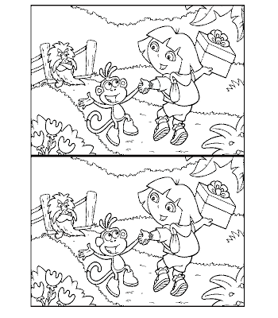
Beijos, tias, Fernanda e Jéssika.

